3.3 Cluster Centers
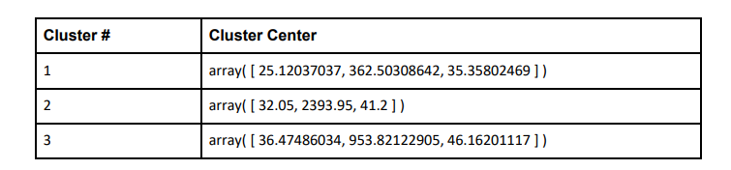

These clusters can be differentiated from each other as follows:
The first number (field 1) in each array refers to the number of ads per user click, the second number (field 2) in each array refers to amount of game-clicking per user and the third number (field 3) is the cost on this game of each user. These clusters can be differentiated from each other as follows: The first number (field 1) in each array refers to the number of ads per user click, the second number (field 2) in each array refers to amount of game-clicking per user and the third number (field 3) is the cost on this game of each user.
Cluster 1 is different from the others in that the users’ ad-clicks, game-clicks and cost are all less than others, this kind of users can be called “low level spending user”.
Cluster 3 is different from the others in that the users’ ad-clicks, game-clicks and cost are all more than others, this kind of users can be called “high level spending user”.
Cluster 2 is different from the others in that the ad-clicks is not the least, game-clicks is the most but their cost is not the most, this kind of users can be called “neutral user”.

